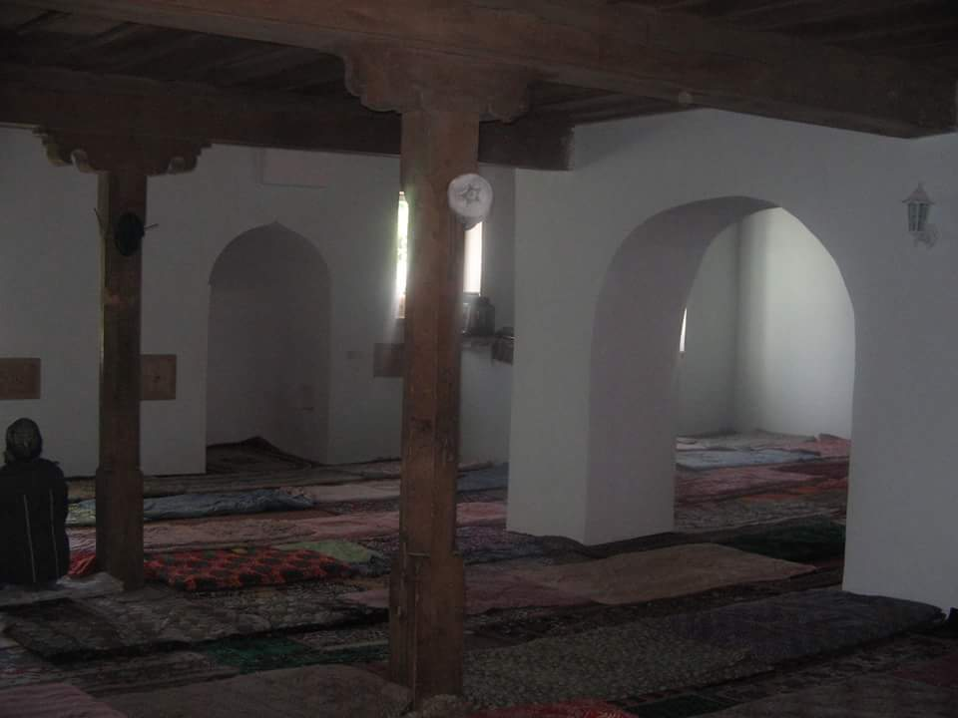
CNIS Working Paper Series Paper № 10

Lack of democracy and radicalization of religious activism in Azerbaijan:
Islamism is knocking at our doors

Hikmet Hadjy-zadeh

Edited by Leila Alieva

The CENTER for NATIONAL and INTERNATIONAL STUDIES

CNIS
Baku, 2016

The CENTER for NATIONAL and INTERNATIONAL STUDIES

Lack of democracy and radicalization of religious activism in Azerbaijan:
Islamism is knocking at our doors

Hikmet Hadjy-zadeh

Edited by Leila Alieva

Islamism is knocking at our doors

"Religion returns to public life and politics around the globe": these were the topics of scientific publications, conferences and headlines in the late 20th century. Contrary to the widespread "secularization theory" according to which modernization, secularization, and economic growth will lead to a decrease in religiosity in society, observers have noted a marked increase in religiosity and radicalism around the world.

Today, the most discussed topic in the scientific and news field is the growth of "Islamism" - Islamic radicalism and fundamentalism, the desire of more and more people to live in a state based on the "fair", "clean", "simple and clear" principles of the Holy Koran. Islamist calls in Azerbaijan, a country that emerged from 70 years of Soviet "scientific atheism" and anti-religious repression, are also becoming louder and louder.

There are several reasons for the growth of Islamist sentiment, such as the protection of traditional identity, the inability and unwillingness to live and work in new industrial and post-industrial conditions; and in authoritarian countries, to which most of the "Muslim countries" belong, it is the fact that religious consciousness and religious activity have no alternatives against the background of suppressed rationalism and democracy. It is generally accepted that the human psyche is experiencing a lot of stress in the absence of spiritual life and social activity, and mysticism and radicalism inevitably start to spread where freedom is suppressed.

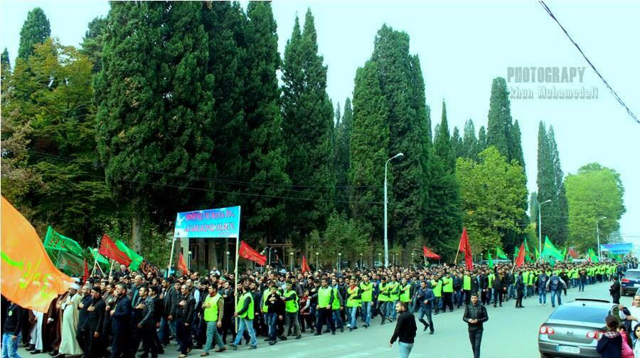
On the eve of the celebration of the Muslim holy month of Ramadan (Eid al-Fitr) in 2015, the Azerbaijani media reported information from the Ministry of Justice, according to which the most common names for newborn boys are such names from the Islamic cultural heritage as Yusif, Ali, Huseyn, Muhammad ... According to media reports, on the first day of Ramadan (18 June 2015), about 10,000 believers gathered for Eid prayers around the city's Ajdar bey mosque designed for no more than 300 people. Another great activity was showed by believers at the time of Ashura - the day of remembrance of the slain Shiite leaders Hasan and Huseyn. On this day (23 May 2015) major funeral processions with banners were held in all major cities of Azerbaijan, speeches full of social protest were made, calls were heard for an end to "all-encompassing corruption and injustice" and demands were put forward for the release of dozens of religious activists arrested "on fabricated charges." Clashes occurred with police in the second most populous city in the country - Ganja - as they tried to disperse an unauthorized funeral procession. Amazing activity was displayed by Azerbaijanis of Georgia who staged a mass funeral procession and a car rally with banners and posters in honour of Ashura in Marneuli (district in Georgia).

https://www.facebook.com/photo.php?fbid=1626436440912238&set=pcb.1067452263287938&type=3&relevant_count=5

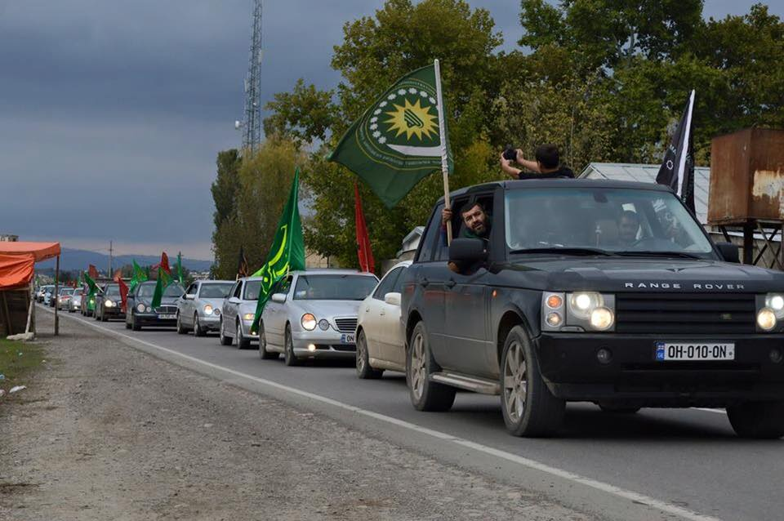

https://www.facebook.com/photo.php?fbid=1625139777708571&set=gm.1065246230175208&type=3

This mass religious activity is taking place against the background of the complete defeat, and, accordingly, silence of the democratic opposition and civil society in the country. As of November 2015, the following people are serving sentences in the country's prisons:

- 12 journalists and bloggers;
- 7 human rights defenders;
- 4 youth activists;
- 5 political activists;
- 38 religious activists;

All these activists are considered political prisoners by Amnesty International.

The above-mentioned religious activity is taking place against the background of the parliamentary elections (1 November 2015) completely controlled by the authorities and boycotted by opposition parties, which representatives of the OSCE refused to observe, considering the environment in which they are held to be anti-democratic.

Significant activity (mass rallies and marches) was observed in honour of Ashura in the village of Nardaran in Baku – a well-known bastion of Shiite conservatism. Observers draw particular attention to a speech at a rally in Nardaran by the new young religious leader Taleh Bagirzadeh (chairman of the Muslim Unity Movement (MUM)), who has just served a two-year term to which he was sentenced, as many believe, for his anti-government sermons. Accusing the authorities of corruption and despotism once again, Bagirzadeh concluded his speech by saying that the fight will continue despite threats of physical violence and even death:

"... Let them know that among our people there are followers of Imam Huseyn [who died in the struggle for justice]. We have people of the same nature as Imam Huseyn. They are ready to die, ready to spill their blood, but they will drown you in their blood ! They will shed their blood, and drown you in this blood."

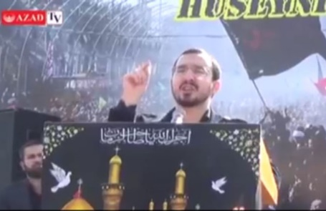

Taleh Bagirzadeh. Nardaran, 23 May 2015

https://www.facebook.com/azadliqqazeti/

Bagirzadeh's speech was interrupted by shouts of support from the mass rally. The rally ended without incidents or police intervention as they believed that it was probably too dangerous to disperse an angry crowd of several thousand people. It is not clear yet what action the authorities will take against Bagirzadeh and his Muslim Unity Movement because usually they do not leave such speeches unpunished. Immediately after the rally in Nardaran, Taleh Bagirzadeh was summoned to the police and beaten up, but was released from the police station in the evening. His deputy Elchin Gasimov was detained by the police and arrested for 30 days for resisting the police. These police actions caused massive protests by MUM supporters who protested in front of the police station until they were dispersed by the police - about 20 protesters were detained by the police.

The Muslim Unity Movement

According to Bagirzadeh, the Muslim Unity Movement (Müsəlman Birliyi Hərəkatı) (MUM) was established in 2014 by him and his associates, when he was serving a two-year term in prison, for the purpose of uniting all the true Muslim forces of the country in the struggle for a just society. The constituent assembly of the movement was held on 13 January 2015, when Bagirzadeh was released from prison. In an interview with Azadlıq newspaper, one of the founders of the movement, Elchin Gasimov, said:

The Holy Koran says that if people do not begin to change their fate, Allah will not change their fate for them. The MUM will cooperate with all the Islamic forces of the country, including the Islamic Party of Azerbaijan. The MUM does not reject national values, but believes that all these values ​​are an integral part of Muslim values. The MUM is against imperialism and cultural imperialism, which is trying to change our traditional identity.

Here are Taleh Bagirzadeh's statements about his vision of the aims of the movement in an interview with Turan news agency:

- Some Muslims, in their manifestation of faith, are content only with the execution of religious rituals – they pray and fast. But this is not enough, because the essence of Islam is to build a just society without lies and violence. A Muslim should not be silent while facing injustice...

- I believe that [traditional] Muslims should adapt to [modern] society and be able to join efforts with other social groups.

- It does not matter whether you are religious or whether you carry out religious rituals, we can unite with you [in the name of common goals].

- The new generation of religious activists understands what is happening in the region and the world. They value human values. They want to put an end to oppression and restore justice. They live with the same problems as all our society. Our main demand, as well as the demand of the whole society, is fair elections.

- I consider terrorist groups operating under Islamic slogans to be enemies of Islam ...

The programme of the MUM was not widely publicized, but, according to the statements of the leaders of the movement, the organization has set itself the following objectives:

- To become a leader of the religious movement in the country, replacing "the Islamic Party of Azerbaijan" as the vanguard of the religious movement in the country;

- To unite all activists and religious groups in the country;

- To overcome the traditional isolation of the Islamic camp from the secular protest movement and establish cooperation with the democratic camp in the country;

- If possible, to unite all the protest forces of the country – both religious and secular.

- To come to power through elections and end oppression and injustice in the country.

It is possible that Bagirzadeh and his supporters have chosen a model of functioning similar to the model of the Turkish Justice and Development Party led by Erdogan. Taleh Bagirzadeh says that he wants to come to power in a coalition with all the progressive forces in the country and through fair elections. "I do not want to establish Shariah law in the country, I just want to put an end to oppression and injustice," Taleh Bagirzadeh said in an interview with well-known democracy activists. Such statements by Bagirzadeh actually mean that he wants to present his movement not as "purely Islamic", but rather as "pro-Islamic".

Time will tell whether this strategy is applicable in a country in which there are no fair elections and in which Islamists have still not renounced their desire to build a state based on Shariah law.

Time will tell whether the MUM will be able to withstand pressure from the authorities and remain a peaceful and moderate pro-Islamic movement to the very end. Today, against the backdrop of the defeat of the democratic camp, the MUM and other Islamist organizations can be one of the few forces that can bring changes to the political situation in the country.

Freedom of religion in independent Azerbaijan

Islamism has the potential to become almost the main opposition actor in the devastated political arena of the country, and all this has happened in spite of the persecution of religion in the last 100 years, both under the Soviets and in independent Azerbaijan.

In the pre-Soviet period, as a result of developments in the Russian Empire, the political and economic situation in the region and under the influence of its own traditions, Azerbaijan formed a strong educational and anti-clerical movement, at the origins of which such thinkers as Mirza Fatali Akhundov, Hasan bey Zardabi, Jalil Mammadguluzadeh and others stood. The desire of society to get rid of medieval religious obscurantism was so strong that this secularist movement became part of Azerbaijani identity and is still strong in modern Azerbaijan.

In the 70-year Soviet period, Islam and respectively Islamic integrism were completely repressed. In the 1.5-million-strong capital of Azerbaijan, there were only two mosques, and the clerics (akhunds) in them were under the strict control of the security services. But even in Soviet times, the struggle of the secularists against "vestiges of the past", for gender equality, rationalism, modernism and "broad views" continued. One of the symbols of this struggle was Sevil - a character of a play under the same title by the famous playwright Jafar Jabbarli (1928), dedicated to the liberation of Azerbaijani women from the bondage of "religious obscurantism." Sevil became so popular that in 1957, a monument was erected to this literary character in the centre of the capital - "Azerbaijani woman taking off the veil"; in 1959, an opera was staged on the same theme; and finally, the future president of Azerbaijan, Heydar Aliyev, named his daughter, who was born at the time, Sevil.

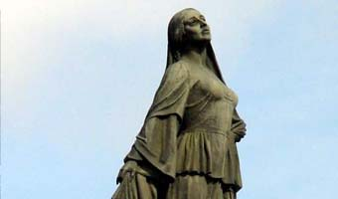

Monument to the liberated woman of the East (Sevil), Baku

It was a golden time for the secularists, when the main tasks were resolved by the Communist government in Moscow.

But with the fall of the communist regime and society gaining some personal and civil liberties, the picture began to change. Religion began to return and occupy a place of honour in society.

If in the Soviet period (before the end of the 1980s) it was dangerous to openly declare your faith in God,

- In 1998, 71% of respondents in a nationwide opinion poll confidently declared their faith in God;

- In 2004, a survey revealed 96.7% of believers;

- According to the nationwide opinion polls (1,000 respondents) we conducted (FAR CENTRE) among the youth of the country in 2010,

95% of young people said they believe in God (2008 - 88%, 2009 - 96%).

However, on average, only 15% of respondents regularly conduct religious rites (2008 - 13%, 2009 - 13%, 2012 - 16.9%).

As can be seen from these data, the growth of religiosity in the country is evident. However, we can make one more conclusion here: the number of deeply religious people (those regularly performing religious rites) over the past 7 years, according to our estimates, has reached a certain level of about 15% of the population and is no longer growing.

In 1992, under the rule of President Elchibey, the parliament passed a law on "Freedom of Religion" and dozens of new religious organizations were registered. In the same year, under a presidential decree, places of worship were returned to believers and religious education became free. Officials began to appear at religious ceremonies and politicians started flirting with the faithful. The Islamic Party of Azerbaijan was officially registered.

However, Iran tried to benefit from the religious factor, spending hundreds of thousands of dollars on promoting an Islamic regime in Azerbaijan, according to press reports. Fearing the growing influence of the ideas of the Iranian Islamic revolution, an anti-democratic provision was introduced in the law on "Freedom of Religion" prohibiting religious leaders from running for parliament. The fear of pro-Iranian religious activity gradually strengthened and the law on "Freedom of Religion" (1992) became subject to constant criticism in society as too liberal.

Meanwhile, President Heydar Aliyev, who came to power in 1993, started a major campaign of repression against his political opponents and any uncontrolled social activity and dissent. Prisons became filled with democratic activists and the media began to be exposed to financial and sometimes physical pressure. Public space - a space for dialogue and mutual understanding - was gradually disappearing.

The new president also focused on the religious sphere. In 1996, the parliament amended the law on "Freedom of Religion" banning the activities of foreign missionaries and local religious communities from registering with centres of traditional religious organizations. Both government and some opposition papers, for fear of the "Iranian" or "Algerian option", often accused religious organizations of activities against the state.

On 15 October 1996, by the decree of the Cabinet of Ministers, foreigners in the country were banned from engaging in religious propaganda. The State Committee for Religious Affairs began re-registration of all religious organizations. The attitude to new religious organizations is based to a large extent on the recommendations of the so-called "mother churches", which, of course, have little sympathy for new and vigorous competitors from abroad.

President Heydar Aliyev started a crackdown on Islamic political activists: he abolished the registration of the Islamic Party in 1995, and in May of the same year, its leaders were arrested. But it turned out that all these repressive measures did not help. Islamic activism and religious extremism continued to grow both worldwide and in Azerbaijan. Deprived of the opportunity to participate in the democratic debate and civic engagement, residents of the country became increasingly closer to religious groups.

The next president, Ilham Aliyev (2003-) had to face armed extremists, and during this period, any uncontrolled religious activity, both Islamic and Christian, began to be persecuted. To suppress terrorist activity, in April 2011 the government carried out a large-scale police operation against Wahhabi groups in the cities of Baku, Ganja and Sumgayit and in Gakh, Zagatala, Sheki, Gusar, Absheron and Khachmaz districts.

However, under the pretext of combating religious terrorism, Islamic democrats (represented by the Juma Mosque community, headed by Ilgar Ibrahimoglu) and believers who did not even claim social influence began to be persecuted in the country. Censorship on religious literature was introduced; independent religious communities started to lose registration; religious leaders who had studied abroad were banned from activities in mosques. There appeared a big problem with hijab (female veil) in schools and universities (2010), which caused strong protests from the faithful. Independent religious communities were closed. Despite the protests of the faithful, the Abu Bakr and Shahidlar mosques were closed in Baku and visits to Ilahiyyat and Fatmei Zahra were temporarily suspended. A few more mosques were demolished as "illegal buildings." And all this was done without any public discussions or negotiations with the religious community.

Islamic political activists

In the course of the struggle for independence (1988-1991), so-called "Islamists" (Islamic political activists) appeared on the political scene and actively supported the secular Popular Front of Azerbaijan. The leader of these Islamists, Haji Alakram, was even elected to the PFA Board and deserved respect among democrats for his activities.

However, in 1991, Haji Alakram and his supporters separated from the PFA and announced the creation of the Islamic Party of Azerbaijan (IPA), which stood out for its extremely pro-Iranian orientation. The aim of the IPA was said to build an Islamic state in the country, based on the model of the Islamic Republic of Iran.

As noted above, the country's new leader, Heydar Aliyev, cancelled the registration of the IPA in 1995, and in May of the same year, nine members of the leadership of the Islamic Party were arrested on charges of collaboration with the Iranian secret services. Political Islam was actually outlawed, but it was impossible to completely suppress IPA activists. They still continue to act in public, although they are occasionally arrested for their protests and statements.

The subject of the protests by IPA activists is mostly social injustice, violation of civil (often election) rights; in foreign policy the IPA acts synchronously with the Iranian government - in support of Palestine and against "world Zionism" and "Western imperialism." And, of course, the IPA continually advocates for religious rights, which according to the IPA, are increasingly violated by the current government.

One of the mass campaigns of the IPA was a series of active protests against the government's ban on girls wearing the hijab in secondary schools (autumn 2010). During these protests, the new leader of the IPA, Movsum Samadov, desperately attacked the president and his family, calling them infidels and enemies of Islam, against whom every Muslim must wage a jihad. Movsum Samadov and people close to him, including his relatives, were arrested (early 2011) and are still under arrest.

Opinion polls do not reveal any significant popularity of the IPA. Nor is the IPA supported by the democratic community of the country. Nevertheless, several hundred activists of the IPA continue their work with perseverance and courage, because, obviously, they can count not on the favour of the voters, but on the favour of God, whom they believe is on their side.

The fight of the IPA on two fronts

The IPA is actually having to fight on two fronts. On the one hand, it is the authoritarian government that tries to stop any uncontrolled activity in any sphere of public life. On the other, it is the influential secularist movement in the country, to which the majority of democrats and the majority of members of the ruling regime belong. Furthermore, opposing any ideas that came from the West, Islamists lost the support of the world democratic community too.

The situation of religious activists is aggravated by "Islamophobia", which developed both worldwide and in Azerbaijan after the 9/11 events.

The Islamic Party of Azerbaijan seeks a way out of isolation

Having undergone repression by the authorities, Islamic Party activists, who remained at liberty and among whom are sincere believers and good people, became a group of outcasts persecuted from all sides. After a year of reflection and soul-searching by mid-1997, a group of IPA activists began work to revive the party.

The new Islamic Party leaders decided to make the following tactical changes:

- To change the name of the party and name it a party of Muslim democrats;

- To adopt a new programme that would give more prominence to democracy, the Constitution and human rights (those words probably had to be repeated more often than usual);

- To try to nationalize their religious propaganda, the well-known Islamic formulas should now be pronounced in the Azerbaijani language, to touch on national problems more;

- To extricate themselves from isolation and enter into an alliance with other opposition forces.

As it became known, within the Islamic Party there was conservative opposition to the new line. And the new party leadership had to manoeuvre between orthodox groups and their challenges that required renewal of the Islamic Party.

As part of the programme to overcome the isolation, the new leaders of the IPA concluded a political agreement on cooperation with the small Liberal and Social Democratic parties in autumn 1997. The papers wrote about these agreements with great surprise and were unable to find out what the liberals and the Islamists had in common.

The next aim of the IPA was the main opposition party - Musavat. After private talks with the leader of the party, Isa Gambar (presidential candidate in the 2003 elections), the Islamists presented a cooperation agreement to the Board of Musavat in early 1998

Under this draft agreement, the IPA and Musavat would undertake the following obligations:

- To strengthen independence, deepen democracy and defend the Constitution;

- To cooperate in the presidential elections in autumn 1998 (meaning that the Islamic Party would support the presidential candidate from Musavat);

- To jointly combat proselytism and non-Muslim sects;

The Musavat Board discussed this agreement for about 2 months. There was nowhere to hurry, because there were still about 9 months to the elections. At first, the desire to get another group of supporters in the presidential election prevailed. It was decided to remove the provision about the joint struggle against missionaries from the text and sign the agreement.

However, in the end, doubts about the ethics of an agreement between democrats and a political organization that had not determined its position yet, forced the governing body of the party to take a different decision.

"We will sign the agreement only when we see that the Islamic Party has become a truly democratic organization and correctly understands the words democracy, constitution and human rights. And therefore, it is first necessary to sign a protocol of understanding with the IPA and on the fact that we share the same values, and only after that, will we be able to cooperate," the Board decided.

Islamic Party leaders were invited to talk with members of the Musavat Board. And I, as a member of the Musavat Board, also participated in it. The conversation turned out to be extremely useful in clarifying the positions of both sides.

It became clear from the conversation that some members of the Islamic Party understood democracy as the democracy of the Iranian regime - the Velayat-e Faqih system. For example, one of the members of the IPA leadership, talking about the essence of the Velayat-e Faqih system, willingly shared with us his thoughts on the fact that "people cannot be allowed to resolve big questions, as they are fallible. There should be religious leaders, theologians (ayatollahs), who determine the framework within which ordinary citizens will be able to vote." After that, it became clear from their words that "if Muslims form the majority in the country, democracy requires us to have Islamic laws too." As for the Constitution, "it can be tolerated today and changed tomorrow according to one's own purposes."

In response to these explanations, members of the Musavat Board presented the guests with the draft protocol of understanding. Its text seemed surprising to the Islamists - "democracy", which seemed simple at first glance, concealed certain "pitfalls".

The text of the Protocol read as follows:

We, the parties that signed the Protocol, admit that

- The rule of the majority should be limited by human rights enshrined in the Universal Declaration of the United Nations.

- Religion is a personal matter and should be separated from the state.

- A person has the right to believe or not and is free to change his religion.

- A person has the right to practice his religion privately or in a group of like-minded people and freely spread his faith regardless of state borders.

- Our goal is Azerbaijan, not the entire Islamic world.

After hearing the arguments of Musavat and taking a copy of the document, the IPA members said goodbye. They promised to study the protocol and express their opinion. The answer was ready surprisingly quickly, the next day. Probably, the IPA ideologists had long prepared these answers:

- The Universal Declaration of Human Rights was written by people, and we recognize only the rights handed over to humans by Allah

- If religion is separated from the state, there is no place for religious people in it and it is a godless state.

- A person is free in his faith (Judaism, Christianity, Islam), but sects are a false faith.

- A person can change his religion by converting from Christianity to Islam, but not vice versa. It is forbidden by the Koran as Islam is the highest and last of the religions.

- A person has the right to practice any of his beliefs in private, but not in a group, and he is not free to disseminate any belief confusing the youngsters and people with imperfect faith.

- Our goal is Azerbaijan and at the same time, the entire Islamic world.

Carefully reading this answer, the Musavat Board came to the conclusion that it was probably a manifestation of the intense internal struggle between supporters of renewal and orthodox groups within the Islamic Party. The agreement has still not been signed.

Foreign missionaries

At the time, the IPA was not the only important Islamic phenomenon in Azerbaijan. Researchers in this field paid close attention to the activity of Islamic missionaries from Iran, Turkey and the Gulf countries in Azerbaijan.

After the fall of the "Iron Curtain", Azerbaijan was flooded by various Islamic missionaries spreading the Turkish (followers of Fethullah Gulen), Iranian and Wahhabi (Salafi) versions of Islam. The latter two were openly and strongly opposed to the secular and modernist course of the country. Iranian religious missionaries in Shiite mosques openly preached ideas of the Islamic Revolution, provided financial aid to their supporters and recruited young students among the population to study in the religious centres of Iran to further use them for their own purposes in Azerbaijan.

Wahhabis were also acting in secret, creating clandestine religious circles, in which they taught their own version of Islam with great success. This doctrine almost openly called for the extermination of all (and, above all, the Shiites) who disagreed with Wahhabism.

The question of how Wahhabism was able to put down roots in a predominantly Shiite country requires a special study. However, soon the government, concerned about the popularity of this trend of Islam, decided to foil the activities of Wahhabi missionaries. They were expelled from the country, but it was too late - Wahhabism (Salafism), sometimes in the most aggressive form, began to spread in Azerbaijan without missionaries.

The 9/11 events further ratcheted up public concern about the possible development of terrorism in the country. Very soon, the public learned that the secret services of the country are fighting armed Azerbaijani Wahhabi and Shiite groups operating in the country or fighting in Chechnya or Afghanistan; one of these Azerbaijani Wahhabis even ended up in the US prison at Guantanamo.

Moderate Muslims - Juma Mosque community in Baku

Members of the Juma Mosque community in the Old Town can rightly be called moderate Muslims and be recognized as part of the democratic movement in the country.

The Juma community (Shiite Muslims) was registered on 25 August 1992 by the Ministry of Justice (under the government of Elchibey). The core of the community were members of the religious organization Islam Ittihad (Islamic Union).
The Islam Ittihad organization was created in 1991 by a group of young religious people under the leadership of engineer Azer Ramiz oglu Samadov. Some activists of Islam Ittihad and Azer Samadov himself were former members of the Popular Front who quit in protest "against violations of strict principles of ethics and democracy by the Front." In 2000, Ilgar Ibrahim oglu Allahverdiyev (born in 1973) was elected imam of the Juma Mosque. He received an economic education at the Institute of Futurology and a theological education at the theological faculty of Tehran University, where he defended his thesis on "Islam and the philosophy of the East: points of contact."

In 2000, members of the community created a right organization concerned with freedom of conscience (DEVVAM). DEVVAM protects not only the religious rights of Muslims, but also followers of other denominations. In 2002, DEVVAM became a member of the International Religious Liberty Association (IRLA) with headquarters in Washington, and Ilgar Ibrahimoglu took over as general secretary of the Azerbaijani branch of IRLA. In 2002, Ibrahimoglu visits the OSCE-sponsored International School of Human Rights in Warsaw led by one of the leaders of the Polish Solidarity - Marek Nowicki. In mid-2004, Ilgar Ibrahimoglu was nominated for the post of official UN rapporteur on religious freedom. However, later he had to withdraw his candidacy due to a brutal crackdown on the community launched by the government in July 2004.

From the very beginning, members of the community rejected the claim of the Department of Muslims of the Caucasus (DMC) to play a dominant role among Muslim organizations and communities confirmed by the law on religion. The community believes that the DMC is controlled by the government and is an extremely corrupt organization.

In the 24 years of its existence, the leadership of the community carried out great historical transformation in its views. The romantic attitude towards the Islamic Republic of Iran turned into a very critical attitude to this regime here. The fight for their religious rights eventually led members of the community to the liberal understanding of human rights. The community began to share and promote liberal ideas, including the idea of a pluralist democratic state in which freedom of religion would be provided for all. The Juma Mosque could be easily visited not only by Shiites, but also by representatives of other currents in Islam.

The social activities of the community were well covered in the press. It is pursuing the following programmes: "Help to thalassemia patients"; "Motherland without orphans"; "The fight against alcoholism and drug abuse"; "Islamic education" and a programme to help needy families.

The religious and ethical views of the community, according to Ilgar Ibrahimoglu, lie in the principle: "Religion and corruption are incompatible." Members of the community strictly kept to this maxim. Juma Mosque community members can be rightly called the first Muslim democrats.

The community of the mosque is managed by an elected imam - from 2000 to this day, it is Ilgar Ibrahimoglu. The permanent number of believers attending Friday prayers at the mosque was about 600.

Repression and persecution have accompanied members of the community almost since its inception. The refusal to follow the "main" Muslim organization and pronounced independence from the state and any older brothers led to the fact that in the mid-1990s, both the pro-government and opposition press accused the community of all kinds of sins and first of all, of pro-Iranian orientation. This situation changed at the end of the 1990s, when the democratic nature of the Juma community, which was unique for religious organizations, became obvious and the progressive part of the civil and political community started to give it all kinds of support. For its part, in their sermons the leadership of the community intensified criticism of corruption and human rights violations in the country.

Support from the democrats of the country, however, increased pressure on members of the community from the government and pro-government media. This pressure particularly intensified in the light of the tragic events of 11 September 2001 when, along with the antiterrorist campaign, a wave of Islamophobia swept through the world, targeting many dissident Muslim activists. Government officials and the media began to spread rumours in society and among the diplomatic corps about the community's links with Iran and their secret activities against the state, while community members welcomed the operation against the Taliban, whom they regarded as people who disgrace Islam, and the campaign to overthrow the bloody dictator Saddam Hussein in Iraq.

It can be said that after the 9/11 events, the crackdown on members of the community was on the rise. Once again, the Ministry of Justice has refused to register the human rights organization DEVVAMM. The DEVVAMM office is periodically raided by the police. Two members of the community were fired due to their membership in the community. A member of the community - the owner of a small shop, who refused to give a bribe to the police for religious reasons, is accused of "resisting the police" and is arrested for 20 days. There are many such cases of persecution. All this is happening against the background of continuous threats from government agencies and the Department of Muslims of the Caucasus, demanding an end to criticism of the government and corrupt official Islam in the country. The government media called Ilgar Ibrahimoglu a Wahhabi, a member of Al-Qaeda, Khomeynist, a Shiite radical and an agent of Western secret services and secret Protestant.

In the presidential elections of 2003, activists of the community totally supported the democratic presidential candidate, and after that, the community was faced with a heavy crackdown. The leader of the community Azer Samadov was forced to leave the country for fear of arrest and found asylum in Europe, and the religious head of the community, Imam Ilgar Ibrahimoglu, was sentenced to 5 years in prison for taking part in the riots that took place the day after the election. But as a result of the international campaign on his behalf, he was released from prison after 4 months.

In 2003, court hearings began on the eviction of the community from the mosque. Despite all appeals from the democratic public of the country and the world, the court, which was entirely controlled by the executive branch of power, decided to evict the community. The eviction took place at the beginning of July 2004. The eviction had the nature of a brutal police action, which was opposed by about 3,000 believers. All democratic organizations and parties of the country, international human rights organizations, Council of Europe and US officials spoke out in defence of the community. However, all this support did not prevent the eviction of the community. During the police operation, more than 70 members of the community were arrested for various brief periods ...
From then until the present day, the community moved on to semi-legal status, holding its religious and social gatherings in private homes.

After his release, Ilgar Ibrahimoglu continued his religious and human rights activity. In answer to our question about the authorities' attitude towards religious organizations, Haji Ilgar noted:

"I do not agree with the opinion that the state treats religious communities based on the extent of their 'traditional' or 'alien' nature. The authorities are simply trying to place all cells of civil society, including religious organizations under their full control. The authorities tolerate only religious organizations (regardless of faith) that actively promote the incumbent regime in their prayers or, in extreme cases, do not show any public activity. In general, the authorities are trying to suppress opposition to government policy in any form, both secular and religious."

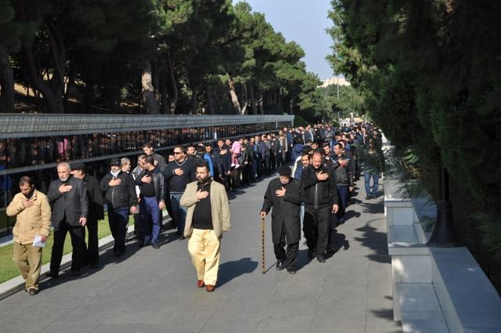

The Juma Mosque community, headed by its leader Ilgar Ibrahimoglu, visits the memorial of the fallen for the independence of the country.

Despite all repression, the Juma community continues to be an integral part of the democratic movement in the country, actively helping democratic candidates in elections and taking part in numerous campaigns in defence of human rights in the country.

The leadership of the community believes that the legislation in the area of ​​religious activities is not consistent with the Constitution, international standards and Azerbaijan's obligations in the field of human rights; it is extremely undemocratic, and only provisions of the laws that limit the freedom of faith are being enforced. Juma community activists criticize the introduction by the government of:

- The demand for the registration of independent religious organizations in the mother church that are under the full control of the government;

- The ban on the participation of religious leaders in the elections to parliament;

- Censorship of religious literature;

- The ban on the wearing of hijab in schools;

- The ban on female citizens to have their photographs taken in hijab for ID cards (passports and other documents)

- The ban on the religious activity of priests who studied abroad;

- Restrictions on freedom of assembly and association ...

In 2004, the community opened the website Deyerler (Values ​​- Azerbaijani) in the Azerbaijani language http://deyerler.org/, which contains news and religious information - clarification on issues of religious practice and religious-ethic sermons.

The defeat of the Turkish sect of Fethullah Gulen ("Hizmət Hərəkatı")

Representatives of the Turkish sect of Fethullah Gulen - "Hizmət Hərəkatı" (Movement of Service [to the people]) appeared in Azerbaijan in the mid-1990s and were welcomed by both the government and society, because according to their activities in Turkey, Gulenists spread ideas of moderate Islam and Turkism. Moreover, the sect had significant support in the secular government of Turkey, which considered the sect to be a successful counterbalance to radical Islam and a good tool to increase Turkish influence abroad.

Gulenists showed almost no public activity in Azerbaijan, turning a blind eye to injustice and corruption prevailing in the country and offering prayers in support of the current government. The leadership of the sect focused mostly on religious and secular education for Muslims.

For radical Muslims who urged the leadership of the sect to finally start a holy jihad for the establishment of a true Islamic state, Gulenists had the following answer ready: "Of course, we will eventually build an Islamic state, but first we need to raise the level of education among Muslims - illiterate people cannot create anything good."

Activists of Hizmət Hərəkatı appeared not only in Azerbaijan but also in former Soviet republics of Central Asia, and with the support of the governments of these countries, they built a huge educational network consisting of about 80 secondary schools and other educational institutions of a secular nature, which, however also covertly taught ideas of ​​"modern (moderate) Islam." In addition, there is a certain number of adherents of the sect among small and medium-sized businesses, and they are also in the law enforcement agencies. The total number of followers of Hizmət Hərəkatı in Azerbaijan is estimated at 10,000 people.

In Azerbaijan, Hizmət Hərəkatı owned 12 secondary schools and gymnasiums, Caucasus University and the Araz educational courses with a total of about 5,000 students. All these institutions stood out for their high level of education and lack of corruption, which was important for students in Azerbaijani realities with a crumbling education system.

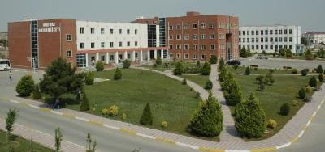

The building and campus of the Caucasus University, Baku

The basic principles of Hizmət Hərəkatı are the following:

- Sunni Islam.
- Rules and customs of the Sufi sect of Nakshibendi.
- Rules and customs of the Nurcu movement (moderate Islam).
- Anti-communism (as opposed to Soviet influence).
- Conservative nationalism - Turkism.
- Pragmatism.
- The adoption of and compliance with international standards of modern capitalism.
- Not to contradict democracy and secularism (in the 1990s, Fethullah Gulen even condemned the protest movement for hijab in Turkish universities).
- Tolerant attitude to Israel.

All these principles synchronized with the principles of the ruling elite of Turkey and Azerbaijan of the time. Thus, Hizmət Hərəkatı was favorably received by the then Azerbaijani President Heydar Aliyev, who said in June 1999: "Fethullah Gulen is needed not only by Turkey and the Turkic world, he is needed all over the world!"

However, Azerbaijani society developed a dual attitude to Hizmət Hərəkatı. On the one hand, everyone recognized the great positive role of the movement in education in the country, but on the other hand, the democrats did not like the conformist position of the leaders of the movement on human rights violations and corruption in the country and, in addition, Shiite religious leaders disliked and, at times, were hostile to Hizmət Hərəkatı, seeing the Gulenists as Sunni rivals in catching the souls of believers. The closed nature of the sect was particularly disliked - in the public sphere it was possible to find a sufficient number of critical articles about Hizmət Hərəkatı, but it was hard to find the reaction of the sect leadership to this criticism. What really happened inside the sect was unknown to the public.

Nevertheless, the Hizmət Hərəkatı school continued to operate successfully. But soon there appeared a more serious accusation against the sect: the leadership of the sect was accused of trying to train a new pro-Gulen elite for the country in their schools, without attracting attention - and implant it in the ruling circles in order to change the system from within. In this case, Hizmət Hərəkatı used the tactics of secret societies (masons, etc.) well-known in the history of Western Europe. The relative calm ended for Hizmət Hərəkatı with the rise of Tayyip Erdogan's party to power in Turkey. They did not share the above principles of Fethullah Gulen. Turkey began a crackdown on the sect. Erdogan launched a real "witch hunt" and purged Gulen's supporters from government agencies. This campaign was called "a fight against parallel structures of power."

Soon Erdogan drew attention to the international network of Hizmət Hərəkatı in the Turkic republics of the former USSR. The new president of Azerbaijan, Ilham Aliyev, was informed by Erdogan about the "Masonic conspiracy" of Hizmət Hərəkatı – about Azerbaijani "parallel structures of power" and was given lists of Azerbaijani officials supporting Gulen. Erdogan strongly advised Ilham Aliyev to expel these people from governmental structures, which is what happened. Azerbaijani society was to learn from government media about the great number of Gulenists in the government and even in the presidential administration and about how dangerous they were.

In March 2014, the government of Ilham Aliyev started a purge - many high-ranking officials who turned out to be supporters of Hizmət Hərəkatı were dismissed. In particular, the head of a department at the presidential administration - Elnur Aslanov, the vice-president of SOCAR - Khalig Mammadov, the chairman of the State Committee for Affairs of Religious Organizations - Elshad Isgandarov, his deputy - Gunduz Ismayilov, Deputy Minister of Youth and Sports - Intigam Babayev, MP Jeyhun Osmanli, the director of the Centre for Strategic Studies under the Presidential Administration - Farhad Mammadov and the chairman of the Youth Fund - Farhad Hajiyev were dismissed from their posts. As for the high quality educational network established by Hizmət Hərəkatı in Azerbaijan, the authorities as usual got their hands on it. Now they have been handed over to the State Oil Company (SOCAR) and continue to operate. For how long?

Thus, after the defeat of the democratic camp, another peaceful, moderate network advocating for civic education was destroyed, and there is no-one but the radical underground to appeal to for spiritual food.

Wahhabis in the Shiite environment

Since the initial period of the independence of Azerbaijan, there have been two main problems in the sphere of religion: the problem of freedom of religion and the problem of religious extremism. And, unfortunately, today the problem of religious extremism has become one of the major problems of our society. Killings and intimidation of opponents; organized terrorist activities; the lack of any tolerance of dissent, unwillingness to engage in dialogue - that's what characterizes the activity of religious extremists in the country today. And even discussing the problems of Islam is dangerous - extremists may immediately declare you an enemy of Islam with disastrous consequences for you.

Nevertheless, the activity of radical Islamists manifests itself more abroad than at home. Apparently, the harsh authoritarian regime does not allow extremists to develop here. Today, our newspapers are full of reports about the latest Azerbaijani groups found on the fronts of jihad in Afghanistan, Syria and Iraq. Others are detained at the border while trying to return home. There are many reports of the trials of local jihadists who have returned after fighting in the Middle East. Both Sunnis and Shiites go to participate in jihad – some for Bashar al-Assad and others against him, fighting on the side of ISIS (Islamic state). According to researchers, about 300 fighters from Azerbaijan (700 people from the UK) are involved in all kinds of jihad today.

In the question of the radicalization of the movements, excerpts from the investigation into the causes of radicalization of an individual and ways of spreading Wahhabism in a Shiite country, conducted at our request by the well-known Azerbaijani journalist Ibrahim Bayandurlu, may be interesting. In his investigation entitled "My Wahhabi friends", Bayandurlu describes the transition from a traditional human Shiite family to the ultra-conservative Sunni wing of Islam - Wahhabism (Salafism), the Sunni community Ahli Sunnah Wal Jama'ah", in which jihadists are mostly recruited.

Excerpts from "My Wahhabi friends" by Ibrahim Bayandurlu:

"... Religion performs a number of functions of both an individual and social nature. Many psychologists tend to assume that religion helps people to formulate and find the meaning of life, feel control over the course of daily routine and protects against the fear of death and uncertainty. For example, this is what Freud believed. Psychologist Spilka believes that religion helps people to overcome their internal shortcomings and weaknesses; however, the scientist warns, this way leads people to rigid, i.e. inflexible religiosity ... too often the result is a tough, inflexible and tyrannical faith. A characteristic feature of this religiosity, which has a neurotic basis, is the image of a formidable, demanding and punishing God used to suppress unacceptable desires."

I am writing this article as a wave of Sunni Islam including of Wahhabi persuasion is spreading in Azerbaijan, swallowing new segments of the Shiite religious community of the country. For me, it turned out to be amazing how quickly this ideology is winning the hearts and minds of Russian-speaking Azerbaijanis, among whom there are many people with a fairly high social and educational level.

There is a new generation of intelligent Sunni preachers in the country who have effectively modernized their methods of propaganda (which we cannot say for Shiite preachers).

Armed with literature of excellent printing quality, they are able to meet almost the entire set of psychological requirements of a believer. Take, for example, the cognitive need of people. All new Sunni literature, whose aim is the initial initiation into Islam (Davat), is based on the consistent refutation of the postulates and stereotypes that were imposed and instilled by the Soviet atheistic school. Skillfully denying conceptually integral atheistic books in Russian, the new preachers immediately manage to reasonably and tenaciously provide any believer with an alternative model of the worldview.

The new ideological Sunni propaganda successfully satisfies such psychological needs as fear of social reality and social tomorrow. This is due to the fact that, for example, often through a scientific-sounding sermon, people are inculcated with skills of psychological self-stabilization and strong belief in the future.

Using such methods, the new Sunni community "Ahli Sunnah Wal Jama'ah" quite effectively solves the problem of daily socially produced neurosis. In the process of at least weekly visits to the mosque, a socially and neurotically infected parishioner often hears good worldly advice and produces negative energy. Generally, Ahli Sunnah Wal Jama'ah, which I am monitoring, has a very strong desire for social solidarity, and it is not by chance that there is an entire layer of young Sunnis in the country interacting in control over separate areas of Azerbaijani business. The community includes not only businessmen. According to my information, more than a third of operatives of the external surveillance service of the Interior Ministry of the Azerbaijan Republic have become followers of Wahhabism (Salafism). I also know senior officials of various departments of the Council of Ministers and law enforcement agencies that have converted to Wahhabism. Furthermore I know some of those who decided to leave public service for religious considerations - "there is too much sin and injustice here" they said. But let's move on to some specific examples, which I happened to run into, my Wahhabi friends.

We are talking about a man aged 29-30, who has been practicing Islam of Wahhabi persuasion for six years. He has a secondary education and studied in a Russian school. Before proceeding to the description of his story, we should say a few words about the biography of his parents, as well as the environment in which his mentality formed before he "came to believe in Allah." Maarif's father, being the son of one of the heads of the law enforcement agencies of Soviet Azerbaijan in the late sixties and early seventies, was a corrupt employee his entire adult life. As with many of these families, theft and embezzlement were elevated to the rank of manhood and the only true formula for success in life. We cannot say that this family lacked accepted morals. They did exist, but mainly played a regulatory role only in marriage and family relations. Islam was the same in this family. Maarif, so to speak, is a Shiite by birth. And in their family, as in many other families, Shiite Islam played the role of a kind of declarative regulator, moralizing human behaviour only in specific domestic situations.

I must say that since adolescence, the protagonist of my story was initiated by his own grandfather, the same high-ranking police officer, into the systematic consumption of alcohol. Granddad, who invited his grandson to parties, was guided by the principle: "he will drink anyway, so it's better if he drinks with me than with others."

The whole ninth and tenth grade of this guy was spent before my eyes at drinking parties and dacha orgies typical of the "golden" Baku youth.

At that time, I talked with Maarif rarely, but for quite a long time. When I asked: Why are you leading an aimless life, not studying and not trying to start a serious business ?, the same answer followed: "It makes no sense. My grandfather and father will do everything for me." And indeed, he entered one of prestigious universities with his father's money and dropped out later. However, by the time Maarif reached 23, his father went bankrupt and was left with just one small shop.

Closer to 1999, Maarif finally became an inveterate drunkard. At the same time, he tried his best to dodge work in his father's shop, while continuing to lead the life of a sybarite. The family, which had moved from a luxurious three-room apartment into a one-room uncomfortable apartment because of debts, was sick of Maarif's binge-drinking and anti-social lifestyle.

However, in late 1999, an incident changed the life of our character. Maarif was once so drunk that when he woke up the next morning, he found himself in the company of homeless alcoholics, who lived in the heart of the city, near the monument to Nasimi.

One of the homeless men, on seeing Maarif's face blue-yellow from the hangover and cold, invited him to drink a small amount of cheap disgusting vodka. Maarif took a sip, but felt sick. He found a little money in his pocket, took a taxi and came home. But there was no one at home. And he went to see a neighbour, with whom he had drunk before and who had started to pray and had been going to the Wahhabi mosque Abu Bakr for a year. This man, 10 years older than Maarif, had known him since childhood. The neighbour let him in. He gave him the opportunity to take a shower and sleep. Waking up, Maarif complained of pain in his heart and a feeling of uncertain fear for his life. The neighbour said that this was not just a physical fear, but fear of Allah who sits in any man, even in an out-and-out atheist. It is the fear of being in hell, which overwhelms everyone, even the most courageous person, at some point.

"What am I to do?" Maarif asked. "Surrender to Allah, come to Sunnah and start praying," the neighbour answered. After these words, the neighbour gave Maarif several books that explained the Islamic version of the universe in plain language and contained Sunni prayers.

Already after a week, Maarif performed the ritual of repentance (Tovbe) consisting of ablution, which must be accompanied by appropriate phrases from the Koran. And from that moment, he began to pray five times a day and follow the basic norms of Sunni Islam. You may ask, what's wrong about it? There is nothing wrong about it. But look at what happened to Maarif later.
Maarif grew a messy Wahhabi beard, stopped watching television and refused almost all sources of local and world information. Moreover, he started to force such an attitude to life on other family members. In the first early phase of his Islamization, Maarif was particularly harsh and radical in the methods of imposing his principles on the family - father, mother, brother and sister. He rowed, demanding that the TV set be shut down if it just showed a concert and grossly interfered with the attire of his mother and sister, who, being traditional Azerbaijani women, dressed modestly anyway. Even unpleasant incidents happened: Maarif could throw his sister's cosmetics into the dustbin or intentionally damage the TV set. He demanded that his father stop selling alcohol and meat products containing pork. Maarif stopped going to weddings and secular celebrations.

An interesting transformation took place in the world outlook of Maarif. His grandfather, whom I have already spoken about, was very fond of Azerbaijani medieval poets Muhammad Fizuli and Imadeddin Nasimi. There was a cult of these thinkers in Maarif's family, and despite the fact that he was a Russian speaker, he knew by heart at least one hundred verses of these poets, which were difficult for him to pronounce. However, after the religious inspiration, he became an ardent supporter of the view common in the Wahhabi environment that Nasimi and Fizuli are infidels (kafirs) that encroached upon the fundamental rules of Sunni Islam. If, before his inspiration, Maarif was a great fan of eastern classical music - mugam, he now called our recitative singing an invention of Satan.

Maarif's views on important historical events that happened in Azerbaijan also fundamentally changed. For example, if before coming to Wahhabism, he revered fighters for independence who gave up their lives when Baku was invaded by Soviet troops on 20 January 1990, as well as the memory of those who fell in the battles for Karabakh, now everything was different. According to Maarif, these heroes are not saints (martyrs), as they gave up their lives not for Allah but in the name of secular values, which is the state independence of Azerbaijan.

Actually, I should note the obvious anti-national and anti-Turkic nature of all these personal transformations in Maarif. For example, he began to dress and promote Arabian clothes. I witnessed real Bedouinization of the household and even eating habits of this man. At the same time, purely Azerbaijani household items or home decorations began to cause sustainable irritation and sometimes even aggression in Maarif.

It is curious that despite all this, Maarif remained a socially useless unit. He refused to work with his father in the shop. Any attempts of friends to find him a job ran into excuses about the presence of elements that ran counter to the norms of Islam in the proposed activity. Maarif continues to live off his parents ..."

Similar stories of human psychological breakdown and transition to a very conservative community are not rare in Azerbaijan. Unfortunately, the author of this material did not describe the further radicalization of individuals such Maarif, i.e. their membership in a certain militant group that is ready to detonate bombs and fight for the principles learned in Ahli Sunnah Wal Jama'ah, although we hear quite a few stories about such cases in society.

Attempts to conduct liberal reform in Muslim practices in Azerbaijan

As the gap in development between the Christian West and Muslim East widened, calls for the modernization of Muslim practices in the Islamic environment grew. Here we can recall the famous thinker and reformer Jamaladdin Afghani (1839 - 1897), who called for the Islamic heritage to be rethought and Muslim practices to be rationalized. In parallel with this process, the movement of pro-European secularists (M. F. Akhundov, I. Gasprinskiy, M. K. Ataturk) developed, and their task was to marginalize religion as much as possible and establish the European legislation and education system in the country. At the same time, for the majority of Muslims, Islam remains an important component of identity and universal refuge from all the crises and stresses of the modern world. Often Islam turned into a banner of struggle against colonialism and (after independence) despotism in a country. But since it proved impossible to build a prosperous "Islamic state" inspired by the Islamic revolution in Iran, calls for reform of Muslim practices were heard again.

By the end of the 20th century, failures in the development of Islamic society formulated the task of reform in the following way: it is impossible to renounce Islam, and if you leave the understanding of Islam in its current, authoritarian state, all hopes for development will fail.

Muslim intellectuals, who appeared in the scene in the last 40 years, began to search for the Islamic roots of pluralistic democracy. Totally accepting Islam as recorded in the Koran and the Sunnah, they are trying to reconcile the unchanging text of the Koran to the changing circumstances of life. The new generation of reformers points out that neither the Koran nor the Sunnah requires the establishment of a political entity. There is no indication there about methods of practical application of the provisions of the Koran. And when the Muslim community faced a specific life issue, the resolution of which required a legislative action, according to the tradition that started at the time of the Prophet Muhammad, the community, in an open debate called Ijtihad, had to draw up a law through the interpretation of the Koran or the Sunnah.

In the West, such contemporary thinkers as the Egyptian reformist theology professor Mohammed Khalaf-Allah, and Iranian theologians Abdul Karim Sorosh and Abdu Hilali-Ansari are well-known.

"Our understanding of religion is in constant development; everything that is based on judgment may be replaced if new judgment is more consistent with public interests," new reformers say. It is clear that the new generation of reformers is in constant confrontation with dogmatists and fanatics who accuse them of heresy - a departure from true Islam. Unfortunately, reformers are still suffering a defeat in this confrontation. Despite the apparent logic of their ideas, they have not seen positive significant development in Islamic societies. On the contrary, we can see their extreme conservatism and fundamentalism increasingly capture public opinion in Islamic countries and even in secular Turkey.

Similar processes (albeit on a smaller scale) can be seen in Azerbaijan, which experienced Soviet atheism. As stated above, religiosity and religious activism are vigorously developing in the country, but all attempts to somehow liberalise Muslim practices are unsuccessful. In this regard, it is worth noting the activities of prominent theologian Nariman Gasimoglu (Gasimzadeh).

Nariman Gasimoglu (1956-) can rightly be considered the first Azerbaijani Muslim democrat. A brilliant Orientalist, theologian and the first translator of the Koran into the modern Azerbaijani language (1989), an active member of the movement for independence and one of the prominent figures of the Popular Front of Azerbaijan Party (PFAP), he continues his mission as a thinker almost on his own – he is a supporter of the liberalization of Muslim practices in the country.

Society first became aware of the reformist views of Gasimoglu from the PFAP concept "On freedom of religion", in which Gasimoglu tried to find a way to reconcile Islamic practices with modernity and pluralist democracy. Gasimoglu wrote:

"My research has never had a purely academic nature ... for my goal was and continues to be promoting the reform of religiosity among Azerbaijanis as much as possible ... my ambitions totally coincide with the strategic objectives of democratization not only in Azerbaijani society, but in a whole geographical area called (conventionally) the Islamic world ... the PFAP concept I proposed about the place of religion in society suggested that a believer gradually renounce Sunnah and give preference to the Koran as a document that is holy and democratic to the greatest extent ... The concept involved the spread of such a mechanism of perception of religious precepts that would restrict the boundaries of Islam within moral, ethical and cultural spheres. Religious interpretations within the framework of Koranic logic we studied focus on a critical review of the current Shariah rules and establishment of universal values ​​of democracy and human freedom from a religious point of view."

Gasimoglu's ideas provoked a fierce attack from traditionalists and fundamentalists. For example, his assertion that the Koran does not say anywhere that a woman must cover her face and just says "Let them cover their breast with a veil" (Surah Nur, 31) caused an uproar among dogmatists, who even began to call for physical violence over Gasimoglu and threatened to kill him on the phone.

However, Gasimoglu continued his reform efforts. In the mid-1990s, he created the Centre for Religion and Democracy, which disseminated his reformist ideas. Gasimoglu is well-known in foreign liberal religious circles. He is a Visiting Scholar at Georgetown and California Universities and a regular participant in international conferences in the United States, Brazil, Germany, England, Scotland, Poland, Hungary, Russia, Kazakhstan, Qatar and Georgia on the problem of adapting Islamic practices to modern conditions.

On his impressions from participation in such conferences, Gasimoglu writes with regret:

"... A lot of research is conducted by Muslim scholars in the United States on the topic of Islam and democracy. There is the Centre for the Study of Islam and Democracy in Washington, which seeks to coordinate studies on this subject, holds conferences and debates with Muslim experts, while in Washington, I had private conversations with these scholars and participated in a variety of presentations on the problems of the Islamic world. Most of them are willing to declare and prove on the basis of individual provisions of Islam that this religion is compatible with well-known democratic values. However, their position is limited to a greater extent to declarative points about the democratic nature of Islam ... The democratic doctrines of Islam they declare, as a rule, do not contain any recognition of the incompatibility of modern Shariah provisions with universally recognized democratic values ​​and the need for at least a selective review of certain religious tenets ...

... In March of last year I took part in the seminar "Ijtihad - Reinterpretation of Islamic principles for the 21st century." The seminar was organized by the initiative group Religion and Peacebuilding at the Institute of Peace & Democracy. The circle of participants looked pretty solid. Along with prominent Islam experts from America, it also covered religious leaders, human rights activists, political analysts and even representatives of the Pentagon. The speakers were unanimous that the principle of "Ijtihad" inherent in Islam (the possibility of interpretation of certain religious tenets that are not related to the foundations of faith) in the spirit of the requirements of time includes a lot of potential for exposing the democratic nature of religion and the transformation of the democratic content of religion into a practical plane. However, things did not go beyond the theories. No answers were given to the questions about what Muslims need to change in their religious practices and what they need to do to make religiosity similar to principles of respect for human rights. Apparently, the rejection of a particular cultural and historical heritage in the religious sphere requires more courage. And of course, this case requires effective support from the state.

I put up my proposals concerning the development of an effective mechanism of Ijtihad for debate by the participants. Referring to these proposals, I should note that they briefly boiled down to the following points:

- discussions regarding Ijtihad cannot be limited to the views of religious scholars and should involve scientists from different fields, human rights activists, politicians, etc., because the right to Ijtihad according to Koranic logic ("everyone has their share in the Koran," says a Koranic verse) is the right of every believer ...

- discussions on Ijtihad must contain specific and open criticism of the Shariah system especially in the part that is alien to the concept of human rights, should get out of the scientific and academic community and become a kind of Ijtihad movement. This movement must be headed by the Muslim intelligentsia, not clerics whose status is not stipulated by the Koran;

- in Ijtihad, preference should be given to the Koran, while the Sunnah and hadiths should be gradually renounced as religious and ideological sources of human rights problems;

- to develop a new approach to defining the interests of the "ummah", which many scientists believe are not compatible with human rights.

My speech about these theses did not cause any special approval or criticism. Scientists generally showed no desire to openly discuss or reject these theses. Only one woman with a headscarf was critical. But I received support from ordinary American Muslims in the audience."

As can be seen, the idea of ​​liberal reforms faces greater psychological difficulties not only among the public but even among Muslim intellectuals. Nevertheless, reformers like Gasimoglu continue their selfless mission despite threats to their lives. For there is no other way out of the impasse of backwardness, in which the modern Muslim world has found itself. You cannot call for acts of violence against fundamentalism or religion like what happened during the communist dictatorships of the Soviet Union and China.

Conclusion

Was it possible to avoid the horrors of terrorist attacks, the war on ISIL and Al Qaeda and the millions of suffering refugees from conflict zones that we see on TV? The answer here is not Stalinism, of course, but democracy and sustainable development, because pockets of the fundamentalist Jihad are in backward, corrupt and dictatorial countries where the regimes destroyed all secular opposition and the scope for any dissent and dialogue. We see a similar picture in Azerbaijan, republics of Central Asia and the Middle East: the right to peaceful assembly and free discussions is rejected; dissent and spiritual life goes underground and can occur only in the religious sphere, which is very difficult for dictatorships to control.

“What else are religious activists in Azerbaijan dissatisfied with ? Walking around the city, I see that the sermons of the new generation of our theologians can be heard from almost every small shop through speakers installed on the street," famous journalist Zamin Haji wrote. "If I put my speaker on the street and broadcast the Bill on Human Rights through it, the police would immediately smash my head with batons."

http://1news.az/society/20150708101708600.html
http://www.azadliq.info/58981.html
http://contact.az/docs/2015/Interview/081300126063az.htm#.VjIL4_krKhd
The poll was conducted in 1998 by the Philosophy Institute of the Academy of Sciences of Azerbaijan
The poll was conducted in 2004 by the FAR CENTRE under the leadership of the author of this article.
The polls were conducted in 2006, 2008, 2009, 2010 and 2012 by the FAR CENTRE under the leadership of the author of this article.
Юнусов А.С. Исламская палитра Азербайджана. – Баку: «Адильоглы», 2012. – ISBN: 978-9953-25-132-6
See.: Фарук Марджан. 1980: Самые трудные годы Гюлена.
Юнусов А.С. Исламская палитра Азербайджана. – Баку: «Адильоглы», 2012.
The personal webpage of Nariman Gasimoglu - http://ngasimoglu.net/kimlik-eng.html
Журнал «III Era», Н. Гасымоглу «Мусульмане и глобализация: проблемы адаптации», Баку 2005.
Ibid
Ibid
Yeni Musavat newspaper, 11.11.2015 http://musavat.com/news/yazarlar/mektebli-hicabi-haqda-teklifim_304413.html?welcome=1

